**RESUME**

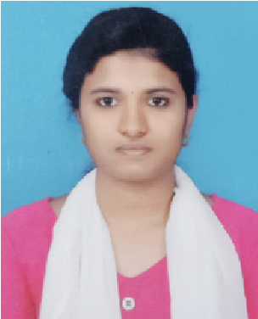

Devika P G

Email Id: devikapg20@gmail.com

Mobile: +91 8015888375

Address: 1A8, Vinayagar colony, Udangudi, Tuticorin district, Tamilnadu-628203

Objective:

Seeking innovative and challenging career in a growing organization which gives me an opportunity to utilize my skills & knowledge and provides me an opportunity for career growth.

Academic Profile:

B.Sc. Computer Science (In progress)-2021-2024

Institution: Wavoo Wajeeha Women's College of arts and science

University: Manonmanium Sundaranar University

12th from Mary Ann Best Girls’ Higher Secondary School

Year of passing:2021

Marks:89%

10th from Mary Ann Best Girls' Higher secondary school

Year of passing:2019

Marks:89%

Technical Expertise:

Programming Languages: Java,C,C++

Web technologies: php,html

Database: MySQL, Oracle

Ms Excel and PowerPoint

Skills:

Good communication skills

Quick learner

Ability to work independently

Soft skills

Achievements

Poster presentation in association competition - 2st prize

PowerPoint presentation in association competition - 1st prize

JCC quest competition - participation

Elocution competition - participation

Personal Information

Father’s name: Gopalakrishnan P K

Date of birth: 30 December 2003

Gender: Female

Marital Status: Unmarried

Nationality: Indian Languages Known: Tamil, English and Malayalam Hobbies: Reading Books,Listening songs

Declaration: All the above information is correct up to my knowledge and I bear the responsibility of the correctness.

Place: Udangudi. Devika P G

Date:25/10/23. SIGNATURE